**Introduction**

*“Stress is the nonspecific response of the body to any demand”*

*- Hans Selye*

Everyone on this planet experiences stress. Present in many forms, it can be found in every aspect of our daily lives. Being trapped in a traffic jam or forgetting to study for a test can make an individual feel “stressed out.” When we hear the word stress, we often associate it with teenagers, especially because of the academic and social pressures of their turbulent, adolescent lives. Their stress can come from being in a fight with friends or forgetting to study for a big test for a few examples. Stereotypically, guys are less emotional and therefore don’t get in fights with their friends as often. They’re also perceived as being less studious and conscientious about their grades and schoolwork. At the moment, “44% of American undergraduates are men. In another decade, the US Department of Education predicts, that number will slip to 42 percent” (www.csmonitor.com). Women are now outnumbering men in colleges and universities. This might mean that men simply are not as smart as women and therefore it is less easy for them to be accepted to college. This could also mean that the male gender places less importance on education. Since women would be more exposed to stress than men, if they were more concerned with academics, would they also be able to cope with it better out of experience? The objective of my experiment is, therefore, to discover which gender manages stress better, males or females?

What defines stress? Anything that is a stressor, a situation in which a person is unable to cope effectively, causes stress. No one is immune to them and no one can avoid them. It can come from natural disasters, such as fires or earthquakes. For teenagers, stressful events can come from the death of a family member, divorce of a parent, or a disability. In adults, stress can be the result of loosing a job, being in debt, even getting married. Although many give stress a negative connotation, stress can also be positive. It is “a normal, adaptive reaction to a threat” (Microsoft Encarta). Eustress, as it is called, forces an individual to face a challenge but not in a way to feel helpless. It causes the person to feel motivated and ready to complete a difficult task (“I can do this!”). Negative stress, distress, makes a person to feel powerless, “causing the brain and body to shrink in its working capacity, resulting in low-performance levels” (http://library.thinkquest.org). The individual feels like he/she is powerless and unprepared (“OHMYGOSH”). Negative stress can include post-traumatic stress disorder. This occurs after an unusually traumatic even, such as a car accident or death of a loved one. Stress that is not correctly handled can also lead to chronic stress. This is long-term stress that happens on a daily basis and comes when the individual gives up trying to solve his/her problem.

*“The worst aspect of chronic stress is that people get used to it. They forget it's there. People are immediately aware of acute stress because it is new; they ignore chronic stress because it is old, familiar, and sometimes, almost comfortable”* (http://helping.apa.org)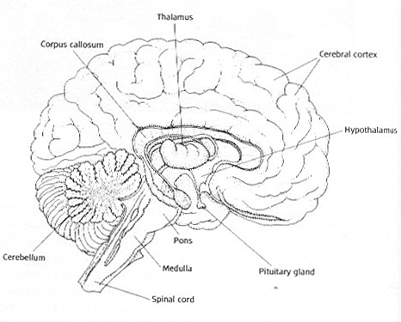

What happens in our bodies as a result of stress? When a person experiences eustress, the body experiences a number of changes in response. This is called the flight-or-fight response because the body can either face the problem or flee from it. The sympathetic division of the autonomic nervous system is triggered and the adrenal glands secrete epinephrine (adrenaline) and norepinephrine (nonadrenaline). “The heart beats more rapidly, muscle tension increases, blood pressure rises and blood flow is diverted from the internal organs and skin to the brain and muscles” (Microsoft Encarta). Respiration and perspiration are also increased and the pupils dilate. The neuroendocrine system, which works with the hypothalamus and pituitary gland, areas in the brain that regulate hormones and other functions, also plays a key role. The hypothalamus signals the pituitary gland to secrete adrenocorticotropic hormone. This hormone directs the cortex (outer layer) of the adrenal glands to release glucocorticoids, mainly cortisol. Cortisol can be harmful, weakening the hippocampus, the part of the brain where the information is stored and that is responsible for memory and the immune system. A weakened hippocampus can, in consequence, result in memory loss and memory lapses teenagers often experience during important tests and exams.

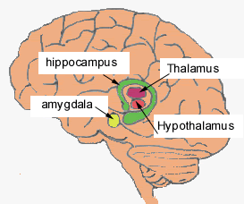

According to Hans Selye, the pioneering Canadian physiologist who first defined stress in the 1930s, the body’s adaptation to a stressor is divided into three stages, the General Adaptation Syndrome: (1) the alarm reaction, (2) the stage of resistance, and (3) the stage of exhaustion (Gordon). In the first stage, the level of adrenocortical hormones in the blood increases. The second stage then begins and the level of adrenocortical hormones decreases. The body is now resistant to the stress, but its ability to withstand other stresses decreases. This could be, for example, a weakened immune system, leaving the person more susceptible to illnesses (Gordon). If the stress lasts for a long time, the individual will move into the third stage, exhaustion. The adrenocortical hormone levels rise again and the body can either help the person adapt to the stress, or the person will surrender to the stress and die.

Outside of the different changes in the nervous system, there are also changes in the behavior of the individual. Those who are often stressed out are disorganized and have a hard time concentrating and remembering things. “Teeth clenching, hand wringing, pacing, nail biting, and heavy breathing are common signs of stress” (Microsoft Encarta). When giving a presentation in front of a class, teenagers often get “butterflies” in their stomach, feel jumpy and have cold hands and feet and dry mouth. These are all the result of the nervousness one feels from the stress.



If the stressor is not solved, stress can lead to a large number of health problems. Some examples are cardiovascular disorders such as hypertension (high blood pressure), coronary heart disease, gastrointestinal disorders (such as ulcers), strokes, diabetes, asthma, arthritis, insomnia, anorexia and obesity. In America, it is estimated that as many as 60 million people have hypertension and ninety percent of those with it did not have any disease that could have caused their increased blood pressure, a sign that it stress could have been an important factor (Gordon). Cortisol, which also impairs the hippocampus, can damage the walls of blood vessels as it increases blood pressure. Stress also “suppresses the activity of the immune system, leaving an organism more susceptible to infectious diseases” (Microsoft Encarta). Students stressing about a test often stay up late studying and are sleep-deprived, which will weaken the immune system. Those under stress also eat less, use more alcohol or drugs and smoke more often, also depressing the immune system. Hormonal changes also impact a persons ability to prevent illnesses. The glucotricoids, such as cortisol, released by the adrenal glands actively suppress the immune system. Emotional disorders can also occur when a person is under stress. They can feel depressed and have an anxiety disorder, phobias or obsessive-compulsive disorder. Those who have survived an extremely tragic experience can also experience post-traumatic stress disorder, such as soldiers who have fought in a war.

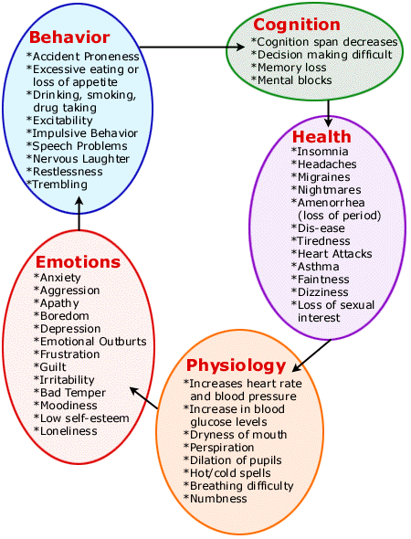

The way to cope with this stress can come in many ways based on the individual’s personality. Those who have high levels of self-confidence can remain optimistic under unpleasant situations more easily. They are also more prepared to cope with the stressors. Those who cannot deal with stress as effectively have lower self-esteem and self-assurance. There are two kinds of coping strategies: problem-focused coping and emotion-focused coping. During problem-focused coping, the individual tries to “modify, avoid or minimize the threatening situation” (Microsoft Encarta). In emotion-focused coping, the individual attempts to solve the problem by directly removing unpleasant emotions. Problem-focused coping is generally the better way to cope with stress as emotion-focused coping can sometimes lead to denial. In problem-focused coping, the individual does not avoid the stress but changes a characteristic of his/her behavior to adapt to the situation. Overall, to cope with stress, the individual should, first, recognize the stressor, be positive and optimistic, plan a response to the stressor, and then slow down and *relax*.